In Hospital Treatment of Status Epilepticus in Dogs and Cats
Filippo Adamo, DVM, DECVN (Neurology)

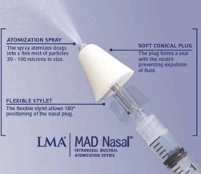
1st line therapy: Midazolam + Phenobarbital
- Midazolam intranasal (using atomizer) 0.2-0.4 mg/kg this is an easy route particularly if the dog is seizing and may facilitate the IV catheter placement.

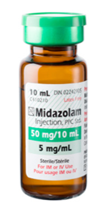

- Followed by Midazolam IV dose: 0.2-0.4 mg/kg bolus

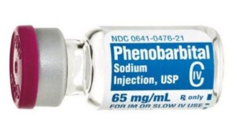
- Followed by Phenobarbital IV:
IV loading dose of phenobarbital (15mg/kg/IV), if patient is not already on phenobarbital therapy.
Alternatively, a bolus of phenobarbital 5mg/kg/IV if patient is already on phenobarbital therapy.

Patient Evaluation:
- If Midazolam is not effective 2 minutes after the 1st bolus, give a 2nd bolus IV of the same dose.
- If still not effective give another bolus (3rd bolus) - max 3 boluses.
- if seizure doesn’t stop after the 3rd bolus it is likely that will not cease with additional boluses, and then 2nd and 3rd line therapy should be started.
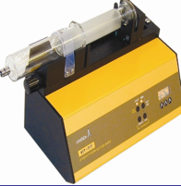
- If seizure stops after the Midazolam bolus, continue with Midazolam IV CRI – use the same dose that was effective to stop the seizures x 4-6 hours - to be tapered by 50% eq 4-6 hours for at least two times before discontinuation.

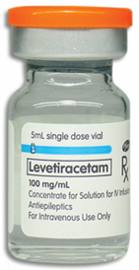
2nd line therapy: Levetiracetam
If Seizures do not stop after 20 minutes of combined Midazolam and Phenobarbital therapy:
add Levetiracetam 60mg/kg/IV bolus:

3rd line therapy – Polytherapy
If Seizures still do not stop 20 minutes after given Levetiracetam IV, then follow with the 3rd line therapy.
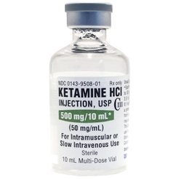
- First Step:
  - Ketamine IV bolus (3-5mg/kg), possibly followed by CRI (0.2-0.6mg/kg/Hour), should be initiated in dogs and cats.

    - If SE persists add:

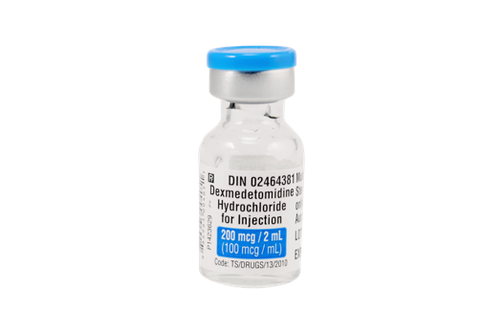
  - Dexmedetomidine IV bolus (375 ugr/kg) and CRI should be initiated in dogs and cats,

(The orders of Ketamine and Dexmedetomidine can also be inverted)

If Seizures still do not stop:
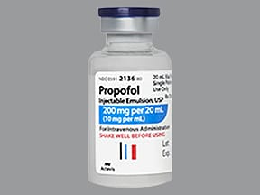
- Second Step:
  - Propofol IV bolus (1-2mg/kg),
  - In dogs: possibly followed by CRI (0.5-0.6mg/kg/min), particularly if SE persists after ketamine and dexmedetomidine IV CRIs.
  - In cats: cautious should be taken with repeated boluses of propofol and particularly with CRI because of safety concerns; efforts should be made to limit the duration of propofol IV CRI in cats to the minimum needed to achieve sustained seizure control

If Seizures still do not stop:
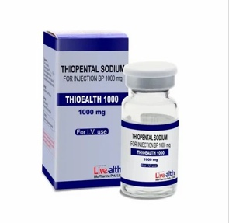
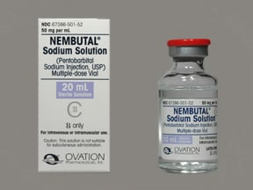
- Thirst Step:
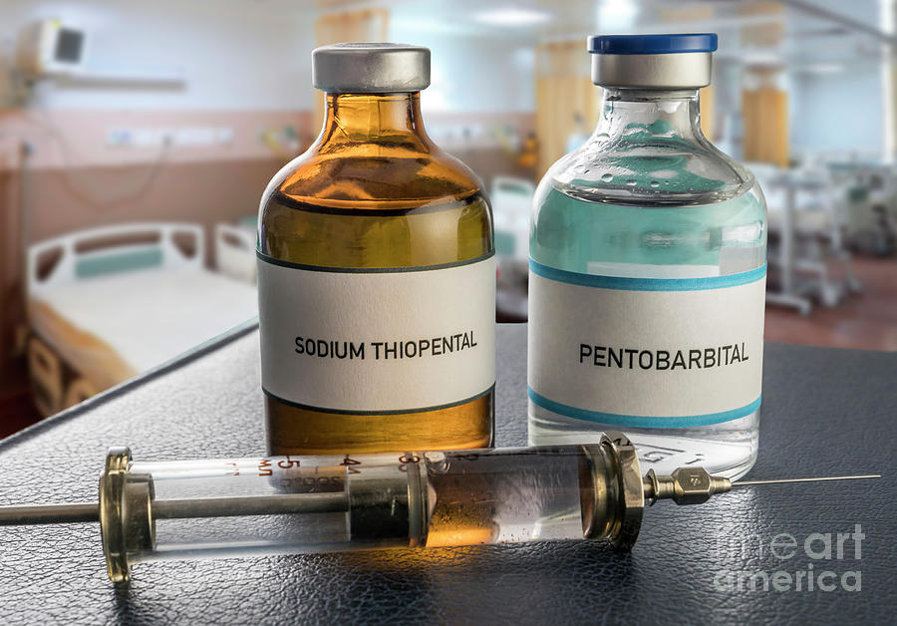
  - Anesthetic barbiturates
  - (pentobarbital or sodium thiopental) in dogs and cats
  - 5-15mg/kg IV bolus
  - +/- CRI if needed

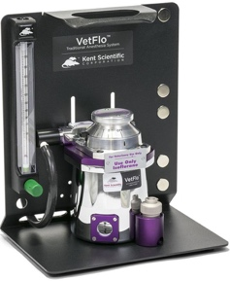
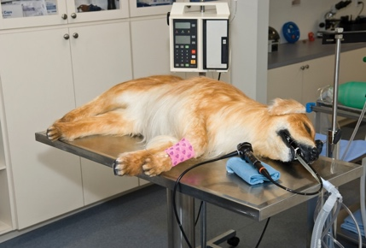
If Seizures still do not stop:
- Four Step
  - Inhalational anesthesia should be initiated in dogs and cats if SE persists after the previous interventions.

What if the Combined Measures with First-, Second- and Third- line treatments as well as supportive care still fail to terminate seizure activities?
- Other pharmacological interventions including but not limited to IV magnesium and allopregnalone can be considered in dogs and cats.
  - Allopregnanolone:
    - 2 mg/kg dose infused over 5 minutes, predicts to obtain the pick concentration as early as 3 minutes into the start of infusion
    - Alternatively: 1mg/kg bolus
  - IV Magnesium

- If these pharmacological interventions fail, non-pharmacological interventions (ie, neurostimulation in dogs and cats) can be considered.

IF SE has been successfully Terminated, how should I taper polytherapy?

- Before starting anesthetic tapering, it is advised that animals be seizure free for 24-48 hour (minimum 12 hours) period.
- After termination of SE, progressive sequential discontinuation of anesthetic drugs should be performed ideally over 24 to 48 hours period, shorter period such as 12 hours also may be considered.
- Simultaneous tapering of more than 1 anesthetic is not recommended.
- Inhalation anesthetic can be discontinued first, followed by propofol or pentobarbital CRI, then ketamine CRI, and lastly dexmedetomidine and Benzodiazepines CRI (ie, in general, opposite to the order in which they were introduced) but variation in the order of discontinuation may apply based on the clinician’s judgment.
- Inhalation anesthetic can be decreased and discontinued more rapidly compared to IV anesthetics.
- A CRI can be decreased by 25% - 50% evert 4-6 hours before discontinuation, if there is no relapse of SE, then the next CRI drug can be tapered in the same manner.
- If seizure activity relapses after discontinuation of a specific anesthetic agent, then its CRI dosage should be increased back to the previous dosage that was sufficient to control seizures (when seizure re-occurred during dosage reduction) or CRI should be re-introduced after a bolus (where seizures re-occurred after complete drug suspension.
- Non-anesthetic ASMs (eg levetiracetam or phenobarbital) should be administrated minimum until the animal is discharged from the hospital (in case with reactive seizures) or over the long-term (in cases with an epilepsy diagnosis) using constant doses and, when applicable) at target serum concentration of the drugs.

